TASK 5.1:MINIMUM SUBARRAY
PROGRAM:
class Solution {
public int maxSubArray(int[] nums) {
int maxSum = nums[0];
int currentSum = nums[0];
for (int i = 1; i < nums.length; i++) {
currentSum = Math.max(nums[i], currentSum + nums[i]);
maxSum = Math.max(maxSum, currentSum);
}
return maxSum;
}
}
OUTPUT:
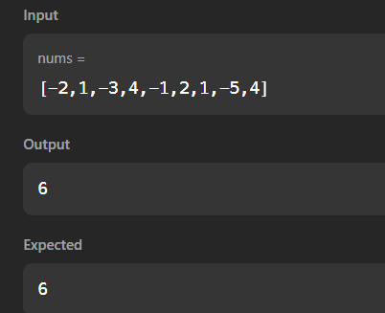
TASK 5.2:THE BIRTHDAY BAR
PROGRAM:
import java.io.*;
import java.math.*;
import java.security.*;
import java.text.*;
import java.util.*;
import java.util.concurrent.*;
import java.util.function.*;
import java.util.regex.*;
import java.util.stream.*;
import static java.util.stream.Collectors.joining;
import static java.util.stream.Collectors.toList;

class Result {
public static int birthday(List<Integer> s, int d, int m) {
if (s.size() < m) return 0;
int currentSum = 0;
int count = 0;
for (int i = 0; i < m; i++) {
currentSum += s.get(i);
}
if (currentSum == d) {
count++;
}
for (int i = m; i < s.size(); i++) {
currentSum += s.get(i) - s.get(i - m);
if (currentSum == d) {
count++;
}
}
return count;
}
}
public class Solution {
public static void main(String[] args) throws IOException {
BufferedReader bufferedReader = new BufferedReader(new InputStreamReader(System.in));
BufferedWriter bufferedWriter = new BufferedWriter(new FileWriter(System.getenv("OUTPUT_PATH")));
int n = Integer.parseInt(bufferedReader.readLine().trim());
List<Integer> s = Stream.of(bufferedReader.readLine().replaceAll("\\s+$", "").split(" "))
.map(Integer::parseInt)
.collect(toList());
String[] firstMultipleInput = bufferedReader.readLine().replaceAll("\\s+$", "").split(" ");
int d = Integer.parseInt(firstMultipleInput[0]);
int m = Integer.parseInt(firstMultipleInput[1]);
int result = Result.birthday(s, d, m);
bufferedWriter.write(String.valueOf(result));
bufferedWriter.newLine();
bufferedReader.close();
bufferedWriter.close();
}
}
OUTPUT:
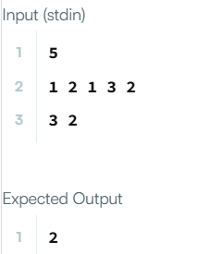
TASK 5.3:MAX SUBARRAY
PROGRAM:
import java.io.*;
import java.math.*;
import java.security.*;
import java.text.*;
import java.util.*;
import java.util.concurrent.*;
import java.util.function.*;
import java.util.regex.*;
import java.util.stream.*;
import static java.util.stream.Collectors.joining;
import static java.util.stream.Collectors.toList;

class Result {
public static List<Integer> maxSubarray(List<Integer> arr) {
int maxContiguous = arr.get(0);
int currentSum = arr.get(0);
for (int i = 1; i < arr.size(); i++) {
currentSum = Math.max(arr.get(i), currentSum + arr.get(i));
maxContiguous = Math.max(maxContiguous, currentSum);
}
int maxNonContiguous = 0;
int maxElement = Integer.MIN_VALUE;
boolean hasPositive = false;
for (int num : arr) {
if (num > 0) {
maxNonContiguous += num;
hasPositive = true;
}
maxElement = Math.max(maxElement, num);
}
if (!hasPositive) {
maxNonContiguous = maxElement;
}
return Arrays.asList(maxContiguous, maxNonContiguous);
}

}
public class Solution {
public static void main(String[] args) throws IOException {
BufferedReader bufferedReader = new BufferedReader(new InputStreamReader(System.in));
BufferedWriter bufferedWriter = new BufferedWriter(new FileWriter(System.getenv("OUTPUT_PATH")));
int t = Integer.parseInt(bufferedReader.readLine().trim());
IntStream.range(0, t).forEach(tItr -> {
try {
int n = Integer.parseInt(bufferedReader.readLine().trim());
List<Integer> arr = Stream.of(bufferedReader.readLine().replaceAll("\\s+$", "").split(" "))
.map(Integer::parseInt)
.collect(toList());
List<Integer> result = Result.maxSubarray(arr);
bufferedWriter.write(
result.stream()
.map(Object::toString)
.collect(joining(" "))
+ "\n"
);
} catch (IOException ex) {
throw new RuntimeException(ex);
}
});
bufferedReader.close();
bufferedWriter.close();
}
}
OUTPUT:
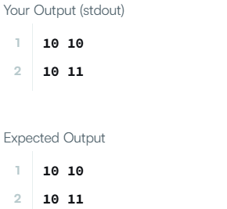
TASK 5.4:MAXIMUM SUM CIRCULAR ARRAY
PROGRAM:
class Solution {
public int maxSubarraySumCircular(int[] nums) {
int totalSum = 0;
int maxKadane = nums[0], currMax = 0;
int minKadane = nums[0], currMin = 0;
for (int num : nums) {
totalSum += num;
currMax = Math.max(num, currMax + num);
maxKadane = Math.max(maxKadane, currMax);
currMin = Math.min(num, currMin + num);
minKadane = Math.min(minKadane, currMin);
}
if (maxKadane < 0) {
return maxKadane;
}
return Math.max(maxKadane, totalSum - minKadane);
}
}
OUTPUT:
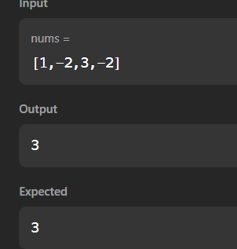
TASK 5.5:STRING TO INTEGER
PROGRAM:
class Solution {
public int myAtoi(String s) {
int i = 0;
int n = s.length();
while (i < n && s.charAt(i) == ' ') {
i++;
}
if (i == n) return 0;
int sign = 1;
if (s.charAt(i) == '+' || s.charAt(i) == '-') {
sign = (s.charAt(i) == '-') ? -1 : 1;
i++;
}
int result = 0;
while (i < n && Character.isDigit(s.charAt(i))) {
int digit = s.charAt(i) - '0';
if (result > Integer.MAX_VALUE / 10 ||
(result == Integer.MAX_VALUE / 10 && digit > Integer.MAX_VALUE % 10)) {
return (sign == 1) ? Integer.MAX_VALUE : Integer.MIN_VALUE;
}
result = result * 10 + digit;
i++;
}
return result * sign;
}
}
OUTPUT:
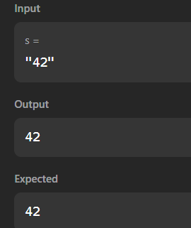
TASK 5.6:ALTERNATING CHARACTERS
PROGRAM:
import java.io.*;
import java.math.*;
import java.security.*;
import java.text.*;
import java.util.*;
import java.util.concurrent.*;
import java.util.function.*;
import java.util.regex.*;
import java.util.stream.*;
import static java.util.stream.Collectors.joining;
import static java.util.stream.Collectors.toList;
class Result {
public static int alternatingCharacters(String s) {
int deletions = 0;
for (int i = 1; i < s.length(); i++) {
if (s.charAt(i) == s.charAt(i - 1)) {
deletions++;
}
}
return deletions;
}
}
public class Solution {
public static void main(String[] args) throws IOException {
BufferedReader bufferedReader = new BufferedReader(new InputStreamReader(System.in));
BufferedWriter bufferedWriter = new BufferedWriter(new FileWriter(System.getenv("OUTPUT_PATH")));
int q = Integer.parseInt(bufferedReader.readLine().trim());
IntStream.range(0, q).forEach(qItr -> {
try {
String s = bufferedReader.readLine();
int result = Result.alternatingCharacters(s);
bufferedWriter.write(String.valueOf(result));
bufferedWriter.newLine();
} catch (IOException ex) {
throw new RuntimeException(ex);
}
});
bufferedReader.close();
bufferedWriter.close();
}
}
OUTPUT:
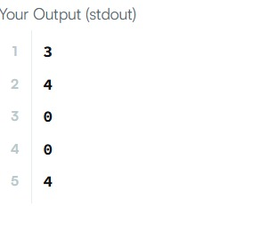
TASK 5.7:LONGEST SUBSTRING WITHOUT REPEATING CHARACTERS
PROGRAM:
import java.util.*;
class Solution {
public int lengthOfLongestSubstring(String s) {
int[] lastSeen = new int[128];
Arrays.fill(lastSeen, -1);
int maxLength = 0;
int left = 0;
for (int right = 0; right < s.length(); right++) {
char curr = s.charAt(right);
if (lastSeen[curr] >= left) {
left = lastSeen[curr] + 1;
}
lastSeen[curr] = right;
maxLength = Math.max(maxLength, right - left + 1);
}
return maxLength;
}
}
OUTPUT:
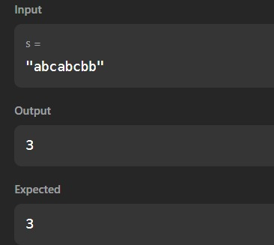
TASK5.8:FIND AND REPLACE PATTERN
PROGRAM:
import java.util.*;
class Solution {
public List<String> findAndReplacePattern(String[] words, String pattern) {
List<String> result = new ArrayList<>();
for (String word : words) {
if (matches(word, pattern)) {
result.add(word);
}
}
return result;
}
private boolean matches(String word, String pattern) {
if (word.length() != pattern.length()) return false;
int[] mapW = new int[256];
int[] mapP = new int[256];
for (int i = 0; i < word.length(); i++) {
char w = word.charAt(i);
char p = pattern.charAt(i);
if (mapW[w] != mapP[p]) return false;
mapW[w] = i + 1;
mapP[p] = i + 1;
}
return true;
}
}
OUTPUT:
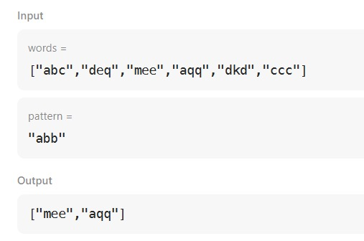
TASK5.9:STRING MATCHING IN AN ARRAY
PROGRAM:
import java.util.*;
class Solution {
public List<String> stringMatching(String[] words) {
// Sort array by word length in ascending order
Arrays.sort(words, Comparator.comparingInt(String::length));
List<String> result = new ArrayList<>();
int n = words.length;
for (int i = 0; i < n; i++) {
for (int j = i + 1; j < n; j++) {
if (words[j].contains(words[i])) {
result.add(words[i]);
break; // Move to the next word once a match is found
}
}
}
return result;
}
}
OUTPUT:
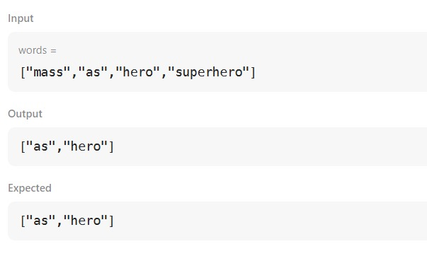
TASK 5.10:NAÏVE ALGORITHM FOR PATTERN SEARCHING
PROGRAM:
OUTPUT:

